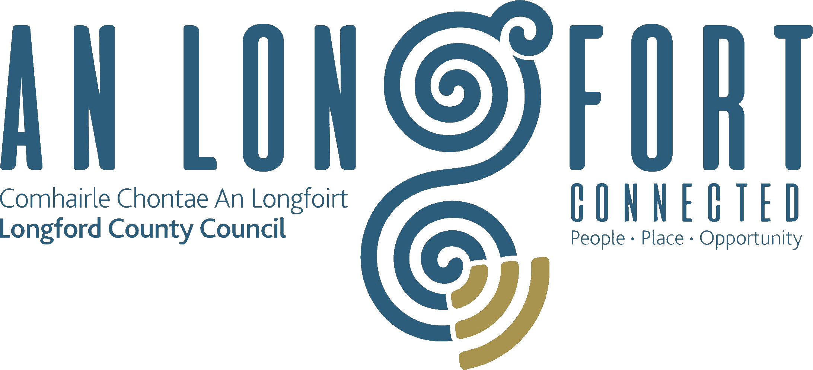

Minutes of Budget Meeting of Longford County Council
held in Longford Rugby Club/via Microsoft Teams on
Monday, 23rd November 2020 at 3.00 p.m.
____________________________________________________________________

PRESIDING: Councillor Paul Ross, Cathaoirleach.

MEMBERS PRESENT: Councillors – Paraic Brady, John Browne, Seamus Butler, Mick Cahill, Mark Casey, Colin Dalton, Gerard Farrell,
Uruemu Adejinmi, Gerard Hagan, Martin Monaghan,
Colm Murray, Garry Murtagh, Turlough McGovern, Peggy Nolan, Pat O’Toole, P.J. Reilly, Paul Ross and Gerry Warnock

IN ATTENDANCE: Mr. Paddy Mahon, Chief Executive.
Mr. John McKeon, Head of Finance.
Mr. John Brannigan, Director of Services.
Ms. Barbara Heslin, Director of Services.
Ms. Maeve Killian, Financial Management Accountant.
Mr. Micheal Hand, Administrative Officer.
Mr. Liam Hand
Ms. Claire McDermott
Mr. Eoghan Dwyer
Ms. Nora O’Farrell
Ms. AnnMarie McKeon
Ms. Lorraine McKee

MEETINGS
ADMINISTRATOR: Ms. Claire McNabola (Acting)

Cathaoirleach Cllr Paul Ross welcomed everyone to the Meeting both present and via MS Teams. Cllr Ross spoke of the unprecedent and challenging year that 2020 has been, he thanked the Members, The Executive and the Employees of Longford County Council for all the hard work over the recent months.

Introduction by the Chief Executive.

Mr. P. Mahon, Chief Executive, thanked the members for their attendance at the Finance Committee meeting and stated that the presentation prepared by the Head of Finance will give an overview on how the Budget for 2021 was prepared. The Budget for 2021 for each Service Division will be presented in turn, allowing the Members to raise specific questions on each Division.

The Chief Executive stated that the Draft Budget to be presented is a realistic one. He stated that we have had a very challenging year and 2021 will also see us facing more significant challenges. The Budget of circa €57 mil is realistic and achievable. Mr Mahon said that after a very difficult few months we have positioned ourselves well to have avoided a deficit. He continued to say that despite the Country been currently under Level 5 restrictions Longford County Council are still providing a full service is most of our areas.

Mr Mahon thanked the Dept of Housing in particular for the financial support that has been received and, in particular, for the significant support through the allocation to Longford County Council to compensate for the loss of rates arising from the closure of the Lanesboro Power Station.

Mr Mahon thanked the Cathaoirleach and Members of the Council for their continued so-operation and support and also thanked John McKeon, his support team, the Directors of Services and their teams for the huge amount of work carried out in preparing the Draft Budget.

2021 DRAFT BUDGET.

Mr. J. McKeon, Head of Finance, thanked the Members for their attendance at the Budget meeting.

He stated that the Budget for 2021 for each Service Division will be presented in turn, allowing the Members to raise specific questions on each Division.

Presentation by the Head of Finance.

Mr. J. McKeon, Head of Finance, stated that expenditure for 2021 is estimated at
€57,229,975.00 and income, including Local Property Tax and other income, is estimated at
€48,452,560.00 which will leave a balance of €8,777,415.00 to be funded by way of Commercial Rates. The General Annual Rate on Valuation required for 2021, on the basis of the Budget, is €0.240.

John outlined the details of the Draft Budget for 2021 under the following headings –

- Budget Book Structure.
- Budget Book Tables.
- Financial Position
- Future Financial Buoyancy
- Challenges & Solutions for 2021
- Covid-19
- Budget Assumptions for 2021
- Rateable Valuation by Property
- Rates Payable by Customer Band
- Impact of Change in Annual Rate of Valuation (ARV)
- Sources of Income
- Income Configuration
- Expenditure by Service Division
- Expenditure Variances by Service Division
- Table D – Income from Goods & Services
- Table E – Income from Grants & Subsidies
- Table F – Analysis of Expenditure & Income by Service Division
- Budget 2021 – Headline Metrics -
  - Budget Expenditure Increased by €9.1m for 2021.
  - €57.23m Budget means – €1,402 spend per citizen, €3,327 spend per LPT Payer, €38,487 spend per Rate Payer.
  - €18m applications for additional grant funding for 2020 and 2021, match funded by +15% LPT Variation.
  - +15% LPT Variation means - €248 extra spend per Citizen, €598 extra spend per LPT Payer, €12,048extra spend per Rate Payer.
- Budget 2021 – Highlights.
  - No Commercial Rates Increase.
  - No Change in Local Property Tax Ratees from 2020
  - No Vacant Property Levy.
  - Continued ability to attract unprecedented levels of funding due to utilisation of Longford Model.
  - General Municipal Allocations remain intact
  - Reasonable expectation of continued Government Support
  - Central Government subsidising lost Rates Income from Lanesborough Power Station (2021)
  - Service Levels maintained and enhanced in some areas.
  - ‘Business as usual’ approach to all Regeneration Projects
  - Further €38.5m in potential projects in pipeline for 2021.
  - No Cutbacks.
  - No Service Suspension.
  - No Austerity.
  - Budget 2021 strategically positions LCC to maximise buoyancy from the better times ahead
- Analyses of Expenditure & Income by Division
  - Housing & Building.
  - Road Transport & Safety.
  - Water Services
  - Development Management.
  - Environmental Services.
  - Recreation & Amenity.
  - Agriculture, Education, Health & Welfare.
  - Miscellaneous Services.

The Members welcomed the Draft Budget which they agreed is robust, visionary, flexible and pro-business. They complimented John McKeon and the Executive on the preparation of the Draft Budget

The Executive replied to the issues raised by the Members, including the following –
- Road Transport & Safety
- Maintenance of Local Authority housing
- EPA Inspections
- Interim Rural Development Programme
- Requirement for Match Funding
- Public Lighting
- Traffic Management
- Energy Retrofits
- Recreational & Amenities – Playgrounds, Walkways & Harbours
- Members’ County Wide Fund
- Environmental Services – Drainage
- FSAI

Adoption of Budget.

It was proposed by Councillor Colm Murray and seconded by Councillor Seamus Butler and unanimously resolved that the Council adopts for the financial year ending 31st December 2021, the Budget set out in Tables A – F, and by Resolution determined in accordance with the said Budget the Rate set out in Table A - €0.240 - to be the annual rate on valuation to be levied for 2021 for the purposes set out in those Tables.

Fix December 2020 Council meeting date for consideration of Chief Executive Annual Progress Report in respect of the Council’s Corporate Plan
It was proposed by Councillor Mick Cahill and seconded by Councillor Peggy Nolan that the Chief Executives Annual Progress Report in respect of the Corporate Plan would be considered at the December meeting of the Council.

Conclusion

Paddy said that the adopted Budget is ambitious, but Longford County Council is “Surviving and Thriving”. He commented that Longford County Council is in an excellent position to kick off 2021. Paddy thanked the Cathaoirleach and Members of the Council for their continued co-operation and support and also thanked John McKeon, the Finance support team, the Directors of Services and their teams for the huge amount of work carried out in preparing the Draft Budget.

Cathaoirleach, Cllr Paul Ross, thanked the Members of the Council for their continued so-operation and support and congratulated John McKeon and the Finance team for an excellent presentation. He thanked John McKeon, The Management Team and their employees for all their work all year and all the work that went into preparing the Draft Budget.

This concluded the business of the meeting.

Signed: Claire McNabola
Claire McNabola
Acting Meetings Administrator.

Confirmed and adopted at Monthly Meeting of Longford County Council held on the
2020.

Signed: _______________
Cathaoirleach.

